# Brain Tumour Classification using Deep Learning for Personal Healthcare

**Paras Chaulagain**

**Information Technology, Charles Sturt University, Sydney, Australia**

[**paras.ch699@gmail.com**](mailto:paras.ch699@gmail.com)

# **Abstract**

Brain tumour classification has been done since long time and still is a trending area of research. But the accuracy and speed are all that matters. What matters is the perfection and pace of the result obtained, specifically in Deep Learning the Convolutional Neural Network (CNN) algorithm is the fastest and most accurate in brain tumour classification. To address these problems in accuracy and speed, Deep Learning technology has been proposed where CNN technique will be used for classification process where any size of brain images is to be processed.

For resizing the image while preserving the aspect ratio ‘opencv’ has been used. For better training, six convolutional networks are applied where relu and softmax activation are applied for better performance with CNN. For regression in CNN ‘adam’ optimizer has been used because of better results gained by other researchers on this. The “adam” optimizer is better for training deep neural network and adapts well. For each parameter, individual learning rate is found easily with ‘adam’. With these it is expected to have high accuracy along with validation, improved processing speed and faster training.

The main contribution is to adopt Convolutional Neural Network in brain tumour classification in personal healthcare.

# **Keywords**

Tumours, Feature Extraction, Convolution Neural Network, Image Segmentation, Image Processing, Deep Learning, Biomedical Imaging

# **Introduction**

There are two types of brain tumours; Malignant and Benign. Malignant is more like spreading tumour, whereas Benign does not spread and is non-cancerous [1]. Classifying images is a sensitive job and must be accurate for correct diagnosis. Even for an expert sometimes the evaluation can be wrong and in a worst-case scenario, the diagnosis fails and leads to death [2].

However, in the medical sector there are numerous patients and segmenting the images is a hideous and time-consuming task and needs an expert to do, so won’t be cost effective either [3]. So, there needs to be a system or a software where brain tumour classification can be done in seconds and prepared for diagnosing the patient [4]. With human involvement it is nearly impossible job to do this accurately in real-time.

The research is more based on finding the tumour by providing various tumours but not the normal brain. It is based on the cancerous tumour malignant and benign the non-cancerous tumour from which it will be easier to make decision. As Deep Learning has achieved big advancements in image processing, the research is based on Convolutional Neural Network which lies under Deep Learning just like other researchers have used, such as [5], [6], and [7].

But unlike other researchers, this research proposes to improve brain image classification by combining neural nets in the same network while resizing the image for faster training, on one hand and high accuracy, on the other hand. In the case of low accuracy, the learning rate is decreased, and epoch is increased which will affect the training time, but GPU processing can overcome this issue in no time.

In summary, the proposed agenda comes with a positive result in successfully classifying the brain tumour with the accuracy of 0.98 with BRATS 2015 dataset where images are differentiated by Malignant and Benign. In conclusion the proposed framework outperforms [8] in accuracy by 12% and validation accuracy by 5% (0.95) even with 10 epochs. Both 240x240 and 512x512 pixels image size has shown similar results.

# **Literature Review**

## Less accuracy in brain tumour classification:

Machine learning is used to help radiologist and physicians identify brain tumour using automated brain tumour classification system whilst improving accuracy. Deep Neural Network is used in Classifying into three different types of tumour (meningioma, glioma, and pituitary) and differentiating into three grades of glioma considering high accuracy. Under machine learning holdout and 5-fold cross validation techniques are generally used for validation in image segmentation to improve accuracy. However, getting high accuracy results with high processing time costs more time [9]. To overcome this, [10] used holdout and 5-fold cross validation techniques to identify brain tumour using automated brain tumour classification system to increase processing speed using matrix computation unlike other researchers used this technique to overcome such issue. These technique results in high potential for image segmentation tasks also. As for [11] used Convolutional Neural Network and imaging technique to multi-classify brain tumour using Deep Neural Network using augmentation technique unlike any other researcher have combined these techniques for multi-classification [12]. These technique results in high potential for image multi-classification tasks as a result [13]. Achieving high accuracy, it results in some limitations such as, increase in processing time for such small dataset and possibility in classifying other biomedical images other than brain tumor. Despite these facts, still holdout and 5-fold cross validation techniques are praised for such high accuracy with improved processing speed [14]. Among other papers no one has tried this process for image segmentation. However, for my project from this research the dataset application process will be very helpful and shadowing and illumination solving process will also be considered [15].

# **Related Work**

Whereas [11] provides high accuracy as well as loss/inaccuracy during validation phase for multi-classification of brain tumour images while using MRI 2D images with multiple datasets using Deep Learning algorithm. It provides feature selection and down sampling, also overfitting is prevented. But, in case of complex MRI images, the proposed method might not give the high accuracy because of small dataset used for first approach [16]. As a result, this research is very similar to my project as I am using the same algorithm it is using. And this research will help me get the dataset which is already trained and the idea about applying the algorithm. It will help me in classifying various types of tumour such as; meningioma, glioma and pituitary including the grades of glioma. On the other hand, [17] provides comparison between different models on segmentation results for brain tumours with better performance and less parameters while using MRI 3D images with BRATS 2015 dataset on SMCSRNet model. It provides stacked brain tumour segmentation using Unet, copy and crop are conserved to maintain multi-scale feature fusion. But, transmission capacity on introducing relevant content of migration learning is comparatively less which results in low performance [18]. As a result, this research will help me understand the segmentation process to be done for image processing. Like [11], [5] provides 3D brain tumour segmentation with increased learning ability by increasing complexity using Convolutional Neural Network while using MRI 3D images with BraTs 2013, 2015 and 2018 datasets on CNN algorithm [19]. It provides, corrected bias field of MRI data, accurate tumour contour, and removed spurious areas. Limitation that this research has is 3D images are not integrated effectively into 3D CNN model. As a result, this research will help my project in understanding the convolution model and how to implement it. [6] has improvised CNN a bit where they provide efficient brain tumour segmentation by reducing redundancy while detecting the tumour with better accuracy using 2PG - Conventional Neural Network while using MRI 2D and 3D images with BraTS 2013 and 2015 datasets respectively with Two-Pathway-Group CNN algorithm. It provides preserved CNN symmetry and local features of an image and larger context are exploited. But conventional CNN model was less efficient in terms of reliability, performance and accuracy [20]. As a result, this research helps my project to learn more about CNN model to increase robustness and accuracy.

Using Deep Learning, MRI brain scans are extracted using feature extraction algorithm to classify MRI brain scans. However, classifying abnormal growth in the brain is the problem. So, [21] provided brain scan classification with high accuracy combining handcrafted and deep image features while using MRI 2D images with BRATS 2013 dataset performed on deep learning algorithm. It provides reduced impact of variations, abnormality and normality of the brain are reduced [22]. But the proposed method cannot be used in variety of sectors because of incompatible datasets [23]. As a result, this research will help my project in learning feature extraction method. However, [8] provided an accuracy of 86% with BRATS 2015 datasets providing medical field multi-modal brain tumour segmentation while using MRI 2D images with RDM-Net algorithm. It provides 0 residual with ResNet, and spatial structure info obtained with spatial fusion block. As a result, this research helps my project to propagate features for brain tumour image recognition [10]. But MRI image can vary which will affect the processing speed while segmenting the brain tumour and accuracy can also be affected directly. This research helps me in strengthening performance of spatial fusion block and the network which is argued to build relation between pixel and region with Residual Dilated Block in the proposed framework. Through Image Augmentation [24] has provided accuracy of 96.70% with sensitivity of 93.67% to 97.48% with BRATS 2016 datasets for medical imaging tasks while using MRI 2D and 3D images with PGGANs algorithm. It provides better GAN/ResNet-50 training and 224 x 224 images are used for better refinement purpose. But visual realism is optimized which doesn’t not maintain diversity and real image distribution is not filled effectively. As a result, this research will help my project on image augmentation for tumour detection [25]. It helps my project in generating realistic/diverse brain MR images separately with or without tumours.

Unlike others, [26] provided better accuracy in detecting brain tumours with sensitivity and specificity improved in the health care sector while using MRI 2D images with machine learning algorithm. It provides self-identification of ROI using OGDMLA and error rate is minimized by optimizing network [27]. But real-time medical application and computation acceleration is not achieved using machine learning for medical image diagnosis which will be very effective to find tumours in real-time for quick response [28]. As a result, this research will help my project in data sample imbalance analysis. This research helps me in identifying tumour images with edge-based image segmentation which uses orthogonal gamma distribution by training the image using machine learning technique. Whereas, combining local binary model and cnn algorithm [7] provided considerable accuracy, sensitivity, specificity and AUC for feature extraction of tumour image for expert diagnosis and self-checking system. They used CT 2D images for training purpose. It provides binary image, more stable model using cross-validation and specific threshold is evaluated using SEN and SPE. But not all the factors of cost are added to the classification process for continuation of the algorithm [29]. As a result, this research helps my project in finding more about convolutional neural network algorithm and how to implement it. It gives me idea on local binary model algorithm used along with CNN (Convolutional Neutral Network) method for feature extraction for tumour classification with CT images in medical field. However, with transfer learning and Content-based Image Retrieval algorithm, [30] has Mean Average Precision/ Accuracy for Content-Based Brain Tumour Retrieval in clinical diagnosis using MRI based 2D images using transfer learning. It provides improved intensity values with normalization and error backpropagation is achieved [17]. But for other body organs, same approach does not support for classification. As a result, this research will help my project in getting idea on transfer learning [31]. It gives me idea on CE-MRI dataset which contains two – dimensional images and three – dimensional volume. Like other researchers mentioned above, [32] provided fair amount of accuracy using CNN models to classify brain tumour in medical diagnosis. They offer to improve not just accuracy but reduce computational complexity, improve true positive and negative rate also. It provides good processing speed for classification purpose. But there are insufficient dataset/images used to classify the tumour which will provide unsatisfactory result if complex MRI images are provided for processing [33]. As a result, this paper is valuable to my project as it provides CNN based classification which needs to be improved.

# 

# **Current Best Model and Issues**

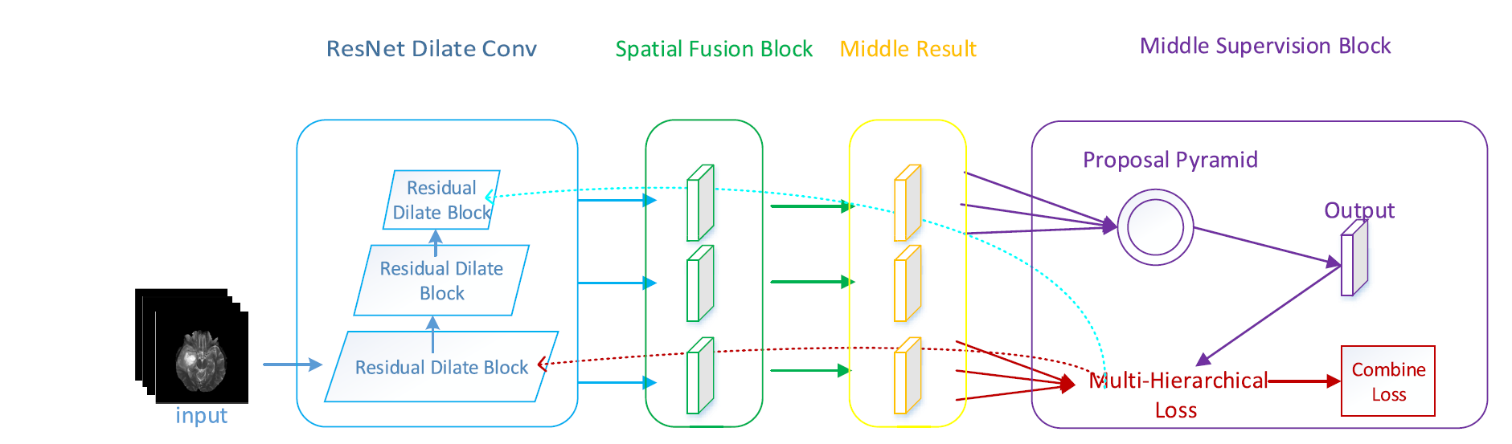

**Fig. 1 Deep Residual Network to Segment Multi-Modal Brain Tumour Images** [8]

The above figure is one of the current best models most suitable for comparing with my framework as it is based on brain tumour detection. Because of some limitations in the above model, I have further researched and applied a different approach for image classification. With the above model the accuracy of 0.86 is low for a brain tumour as it is linked with the health of human. A simple mistake can cost person his/her life. Along with less accuracy, the above model has a low processing speed where a definite image size of 240 X 240 is to be processed for training and testing to get result. Whereas, brain images can be of different size in pixels in real medical field.

# 

# **Solution for the Current Best Model**

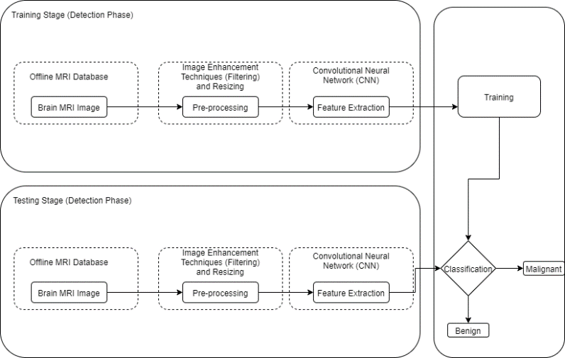

**Fig. 2 Brain Tumour Classification using Deep Learning based on Convolution Neural Network Algorithm**

To overcome the above issues, we have proposed this framework where images are pre-processed from offline MRI Database (BRATS 2015) which includes multiple images of 220 patients whilst resizing the image to 240 X 240 and using CNN for feature extraction and sent it for training and then classification. After that, with the same process done with testing images the images are sent for classification and compared with the training model. Result will be the two types of tumours; Malignant and Benign. Compared to the above current model, the accuracy of 0.98 is obtained from my proposed framework along with the validation of 0.95 with the capabilities of processing any size of images.

Again, we have used the same dataset and trained the model in 512 X 512 using same process to see if it can cope up with different image size which is also the future work of the current best model.

To obtain the above result we have used OpenCV for resizing the image while preserving the aspect ratio. For training we have used tflearn library based on tensorflow and six convolutional neural net of CNN algorithm for feature extraction. For plotting we have used matplotlib library in Python IDE while combining everything in a single program.

# **Experiments**

## **Datasets**

BRATS 2015 dataset has been chosen for the classification where 220 patient’s MRI images are used, each 14 per patients. With total of 3080 MRI images of 512x512 the images are used as a training data.

For the research, BRATS 2015 dataset has been classified into two categories; Malignant tumour and Benign Tumour where, malignant tumours invade its surrounding tissues and benign tumours does not invade surrounding tissues and is non-cancerous.

Online link for BRATS 2015 dataset; https://www.virtualskeleton.ch/BRATS/Start2015.

## **Evaluation**

To measure the overlap area DSC (Dice Similarity Coefficient) is used between the manual and automatic classification results as:

DSC=2TP/(FP+2TP+FN) (1)

Where, TP is true positives, FP is false positives and FN is false negatives.

## **Algorithm for CNN:**

1. Input an image
2. To create a feature map, apply different filters
3. To increase non-linearity, apply ReLU function using;

f(x) = max(o,x) (2) or f(x) = tanh (x) (3)

1. To each feature map, apply a pooling layer using;

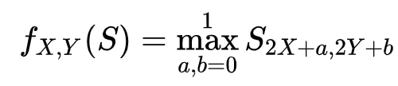 (4)

1. To create one long vector, pooled images are to be flattened.
2. Vector is input into fully connected neural network
3. To get “voting”, features are processed through the network.
4. Until and unless we get well-defined neural network having feature detectors and trained weights, CNN trains through back and forward propagation for multiple epochs.

# **Train Details, Results and Discussion**

In this paper, as for optimization we have chosen the Adam optimizer with 6 convolutional networks with 0.03 learning rate (i.e. le-3). The program is executed in Python with tflearn library which contains Tensorflow from Google. Training has been done on CPU (Central Processing Unit) with 8 GB of DDR3 RAM. For resizing OpenCV library has been used with aspect ratio unaffected.

|  |  |  |
| --- | --- | --- |
| DSC Score | | |
|  | 5 epochs | 10 epochs |
| ResNet | 0.7621 | 0.7827 |
| Res-D | 0.831 | 0.8702 |
| Res-DM | 0.7845 | 0.8503 |
| Res-DMS | 0.7937 | 0.8713 |
| Res-DMSI | 0.8073 | 0.8555 |
| Our Framework | 0.9414 | 0.9804 |

**Table 1. DSC Score performance on tumour classification on BRATS 2015 datasets on 240x240 images.**

The above table depicts the Dice Score Coefficient for various algorithm/techniques. It shows the accuracy on validation data using training dataset with 5 and 10 epochs respectively. ResNet shows the lowest accuracy on 240x240 images with highest of 0.7827 on 10 epochs, Res-D gives accuracy of 0.8702 which is better than ResNet, Res-DMSI and Res-DM whereas, Res-DMS gives the highest accuracy among “Res” technique of 0.8713 even the though Res-D performed accuracy of 0.831 on 5 epochs. Beating all other algorithms/techniques, our framework (CNN) comes at the top where it provides accuracy of 0.9414 and 0.9804 on 5 and 10 epochs respectively.

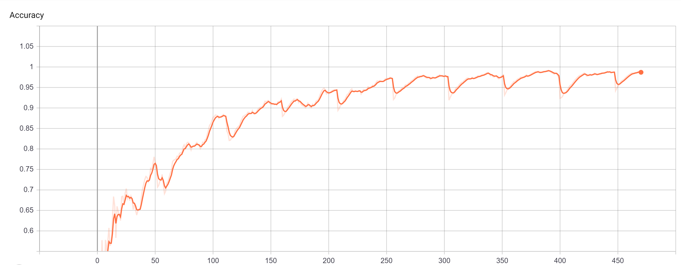

**Fig. 3 Final accuracy chart on brain tumour classification on BRATS 2015 datasets. The above figure shows promising accuracy of 0.98 on 240x240 pixels on training image. To get the accuracy chart Google’s “TensorBoard” was used on localhost where “6006” was used as a default port.**

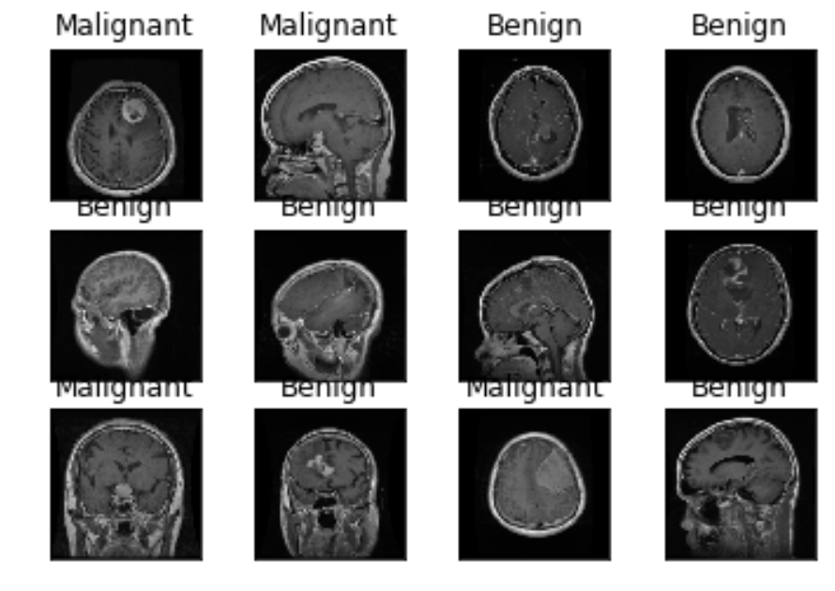

**Fig. 4 Final testing on test dataset using CNN with 10 epochs on 240x240 images.**

|  |  |  |
| --- | --- | --- |
| DSC Score | | |
|  | 5 epochs | 10 epochs |
| ResNet | 0.7621 | 0.7827 |
| Res-D | 0.831 | 0.8702 |
| Res-DM | 0.7845 | 0.8503 |
| Res-DMS | 0.7937 | 0.8713 |
| Res-DMSI | 0.8073 | 0.8555 |
| Our Framework | 0.9448 | 0.9851 |

**Table 2. DSC Score performance on brain tumour classification on BRATS 2015 datasets on 512x512 images.**

Everything like Table 1, just the image pixel was changed to 512 X 512 where the framework also performed well with few more points but approximately it is similar as processed with 240 X 240 images.

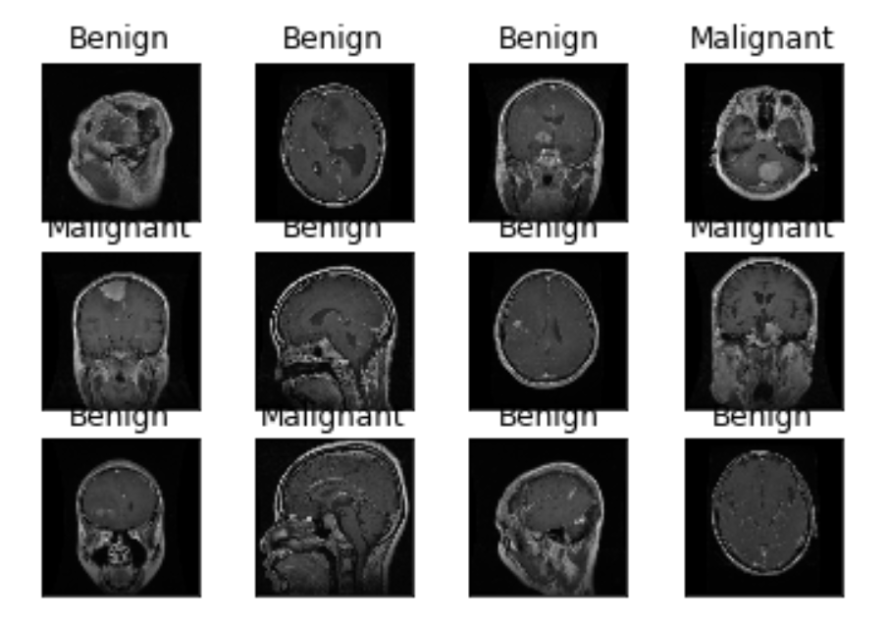

**Fig. 5 Final testing on test dataset using CNN with 10 epochs on 512x512 images.**

|  |  |  |  |  |
| --- | --- | --- | --- | --- |
| **Name** | **Convnet** | **No. of filters** | **Filter Size** | **Activation** |
| convnet | 2d | 32 | 5 | Relu |
| convnet | 2d | 64 | 5 | Relu |
| convnet | 2d | 128 | 5 | Relu |
| convnet | 2d | 64 | 5 | Relu |
| convnet | 2d | 32 | 5 | Relu |
| convnet | fully_connected | 1024 | - | Relu |
| convnet | fully_connected | - | 2 | softmax |

**Table 3. Above table shows the multiple convolutional networks with no. of filters, filter size and activation used for both 240x240 and 512x512 pixels images on BRATS 2015 dataset.**

The above table illustrates that convnet network was used with multiple no. of filters with its size to gain higher accuracy. Two kinds of activation were used; relu and softmax where relu stands for “rectified linear unit” and softmax is also known as “normalized exponential function” which takes vector of K real numbers as input. The table is used for both 512 X 512 and 240 X 240-pixel images.

# **Conclusion**

A novel framework is proposed in this research paper called Convolutional Neural Network for classification of brain tumour. Brain image classification has been improved by combining neural nets in the same network 6 multiple times while resizing the image for faster training and high accuracy in other hand. The learning rate was decreased from 0.05 to 0.03 for better training and accuracy while using GPU for faster training. With ‘relu’ activation with convolutional filter of 32, 64, 128 on conv_2d with size of 5 and ‘relu’ activation with convolution filter of 1024 on fully_connected. Using ‘adam’ optimizer on regression is defined for adaptive training. For training purpose, image size is resized to 240 X 240 pixels for faster training and high accuracy. Also, 512 X 512 pixels images are used for training and testing purpose to check its ability in processing different image size. OpenCV is used for resizing the train and test image for broad classification. By comparing with the BRATS 2015 dataset, the proposed framework comes with the better performance and the highest accuracy even with CPU based processing at 10 epochs.

# **Future Work**

In addition, as the BRATS 2015 dataset contains brain scan images of 512 x 512, the proposed framework cannot be used in other tumours other than brain tumours. Therefore, adopting the program for various tumours other than brain tumour is the future work for researchers to do­­.

# 

# **References**

[1]L. Ale, N. Zhang, H. Wu, D. Chen and T. Han, "Online Proactive Caching in Mobile Edge Computing Using Bidirectional Deep Recurrent Neural Network", *IEEE Internet of Things Journal*, vol. 6, no. 3, pp. 5520-5530, 2019. Available: 10.1109/jiot.2019.2903245 [Accessed 7 February 2020].

[2]M. Anthimopoulos, S. Christodoulidis, L. Ebner, T. Geiser, A. Christe and S. Mougiakakou, "Semantic Segmentation of Pathological Lung Tissue With Dilated Fully Convolutional Networks", *IEEE Journal of Biomedical and Health Informatics*, vol. 23, no. 2, pp. 714-722, 2019. Available: 10.1109/jbhi.2018.2818620 [Accessed 8 February 2020].

[3]H. Jalab and A. Hasan, "Magnetic Resonance Imaging Segmentation Techniques of Brain Tumors: A Review", *Archives of Neuroscience*, vol. 6, no., 2019. Available: 10.5812/ans.84920 [Accessed 8 February 2020].

[4]D. Cheng, X. Zhang and X. Xu, "An Improved Recognition Approach for Noisy Multispectral Palmprint by Robust L2 Sparse Representation with a Tensor-Based Extreme Learning Machine", *Sensors*, vol. 19, no. 2, p. 235, 2019. Available: 10.3390/s19020235 [Accessed 8 February 2020].

[5]K. Hu et al., "Brain Tumor Segmentation Using Multi-Cascaded Convolutional Neural Networks and Conditional Random Field", *IEEE Access*, vol. 7, pp. 92615-92629, 2019. Available: 10.1109/access.2019.2927433 [Accessed 8 February 2020].

[6]M. Razzak, M. Imran and G. Xu, "Efficient Brain Tumor Segmentation With Multiscale Two-Pathway-Group Conventional Neural Networks", *IEEE Journal of Biomedical and Health Informatics*, vol. 23, no. 5, pp. 1911-1919, 2019. Available: 10.1109/jbhi.2018.2874033 [Accessed 9 February 2020].

[7]A. Yang, X. Yang, W. Wu, H. Liu and Y. Zhuansun, "Research on Feature Extraction of Tumor Image Based on Convolutional Neural Network", *IEEE Access*, vol. 7, pp. 24204-24213, 2019. Available: 10.1109/access.2019.2897131 [Accessed 9 February 2020].

[8]Y. Ding, C. Li, Q. Yang, Z. Qin and Z. Qin, "How to Improve the Deep Residual Network to Segment Multi-Modal Brain Tumor Images", *IEEE Access*, vol. 7, pp. 152821-152831, 2019. Available: 10.1109/access.2019.2948120 [Accessed 9 February 2020].

[9]X. Bai, Y. Zhang, H. Liu and Z. Chen, "Similarity Measure-Based Possibilistic FCM With Label Information for Brain MRI Segmentation", *IEEE Transactions on Cybernetics*, vol. 49, no. 7, pp. 2618-2630, 2019. Available: 10.1109/tcyb.2018.2830977 [Accessed 8 February 2020].

[10]A. Gumaei, M. Hassan, M. Hassan, A. Alelaiwi and G. Fortino, "A Hybrid Feature Extraction Method With Regularized Extreme Learning Machine for Brain Tumor Classification", *IEEE Access*, vol. 7, pp. 36266-36273, 2019. Available: 10.1109/access.2019.2904145 [Accessed 8 February 2020].

[11]H. Sultan, N. Salem and W. Al-Atabany, "Multi-Classification of Brain Tumor Images Using Deep Neural Network", *IEEE Access*, vol. 7, pp. 69215-69225, 2019. Available: 10.1109/access.2019.2919122 [Accessed 9 February 2020].

[12]S. Hussein, P. Kandel, C. Bolan, M. Wallace and U. Bagci, "Lung and Pancreatic Tumor Characterization in the Deep Learning Era: Novel Supervised and Unsupervised Learning Approaches", *IEEE Transactions on Medical Imaging*, vol. 38, no. 8, pp. 1777-1787, 2019. Available: 10.1109/tmi.2019.2894349 [Accessed 8 February 2020].

[13]Y. Ding, F. Chen, Y. Zhao, Z. Wu, C. Zhang and D. Wu, "A Stacked Multi-Connection Simple Reducing Net for Brain Tumor Segmentation", *IEEE Access*, vol. 7, pp. 104011-104024, 2019. Available: 10.1109/access.2019.2926448 [Accessed 8 February 2020].

[14]B. de Vos, J. Wolterink, P. de Jong, T. Leiner, M. Viergever and I. Isgum, "ConvNet-Based Localization of Anatomical Structures in 3-D Medical Images", *IEEE Transactions on Medical Imaging*, vol. 36, no. 7, pp. 1470-1481, 2017. Available: 10.1109/tmi.2017.2673121 [Accessed 8 February 2020].

[15]A. Basher et al., "Hippocampus Localization Using a Two-Stage Ensemble Hough Convolutional Neural Network", *IEEE Access*, vol. 7, pp. 73436-73447, 2019. Available: 10.1109/access.2019.2920005 [Accessed 8 February 2020].

[16]R. Hettiarachchi and J. Peters, "Voronoï region-based adaptive unsupervised color image segmentation", *Pattern Recognition*, vol. 65, pp. 119-135, 2017. Available: 10.1016/j.patcog.2016.12.011 [Accessed 8 February 2020].

[17]Y. Ding, F. Chen, Y. Zhao, Z. Wu, C. Zhang and D. Wu, "A Stacked Multi-Connection Simple Reducing Net for Brain Tumor Segmentation", *IEEE Access*, vol. 7, pp. 104011-104024, 2019. Available: 10.1109/access.2019.2926448 [Accessed 9 February 2020].

[18]T. Chiang, Y. Huang, R. Chen, C. Huang and R. Chang, "Tumor Detection in Automated Breast Ultrasound Using 3-D CNN and Prioritized Candidate Aggregation", *IEEE Transactions on Medical Imaging*, vol. 38, no. 1, pp. 240-249, 2019. Available: 10.1109/tmi.2018.2860257 [Accessed 8 February 2020].

[19]K. He, X. Cao, Y. Shi, D. Nie, Y. Gao and D. Shen, "Pelvic Organ Segmentation Using Distinctive Curve Guided Fully Convolutional Networks", *IEEE Transactions on Medical Imaging*, vol. 38, no. 2, pp. 585-595, 2019. Available: 10.1109/tmi.2018.2867837 [Accessed 8 February 2020].

[20]H. Chen, Q. Dou, L. Yu, J. Qin and P. Heng, "VoxResNet: Deep voxelwise residual networks for brain segmentation from 3D MR images", *NeuroImage*, vol. 170, pp. 446-455, 2018. Available: 10.1016/j.neuroimage.2017.04.041 [Accessed 8 February 2020].

[21]A. Hasan, H. Jalab, F. Meziane, H. Kahtan and A. Al-Ahmad, "Combining Deep and Handcrafted Image Features for MRI Brain Scan Classification", *IEEE Access*, vol. 7, pp. 79959-79967, 2019. Available: 10.1109/access.2019.2922691 [Accessed 8 February 2020].

[22]L. Chen, G. Papandreou, I. Kokkinos, K. Murphy and A. Yuille, "DeepLab: Semantic Image Segmentation with Deep Convolutional Nets, Atrous Convolution, and Fully Connected CRFs", *IEEE Transactions on Pattern Analysis and Machine Intelligence*, vol. 40, no. 4, pp. 834-848, 2018. Available: 10.1109/tpami.2017.2699184 [Accessed 8 February 2020].

[23]S. Hashemi, S. Mohseni Salehi, D. Erdogmus, S. Prabhu, S. Warfield and A. Gholipour, "Asymmetric Loss Functions and Deep Densely-Connected Networks for Highly-Imbalanced Medical Image Segmentation: Application to Multiple Sclerosis Lesion Detection", *IEEE Access*, vol. 7, pp. 1721-1735, 2019. Available: 10.1109/access.2018.2886371 [Accessed 8 February 2020].

[24]C. Han et al., "Combining Noise-to-Image and Image-to-Image GANs: Brain MR Image Augmentation for Tumor Detection", *IEEE Access*, vol. 7, pp. 156966-156977, 2019. Available: 10.1109/access.2019.2947606 [Accessed 8 February 2020].

[25]E. Gibson et al., "NiftyNet: a deep-learning platform for medical imaging", *Computer Methods and Programs in Biomedicine*, vol. 158, pp. 113-122, 2018. Available: 10.1016/j.cmpb.2018.01.025 [Accessed 8 February 2020].

[26]G. Manogaran, P. Shakeel, A. Hassanein, P. Malarvizhi Kumar and G. Chandra Babu, "Machine Learning Approach-Based Gamma Distribution for Brain Tumor Detection and Data Sample Imbalance Analysis", *IEEE Access*, vol. 7, pp. 12-19, 2019. Available: 10.1109/access.2018.2878276 [Accessed 9 February 2020].

[27]F. Ghesu et al., "Multi-Scale Deep Reinforcement Learning for Real-Time 3D-Landmark Detection in CT Scans", *IEEE Transactions on Pattern Analysis and Machine Intelligence*, vol. 41, no. 1, pp. 176-189, 2019. Available: 10.1109/tpami.2017.2782687 [Accessed 8 February 2020].

[28]S. Chen, C. Ding and M. Liu, "Dual-force convolutional neural networks for accurate brain tumor segmentation", *Pattern Recognition*, vol. 88, pp. 90-100, 2019. Available: 10.1016/j.patcog.2018.11.009 [Accessed 8 February 2020].

[29]B. Farahani, F. Firouzi, V. Chang, M. Badaroglu, N. Constant and K. Mankodiya, "Towards fog-driven IoT eHealth: Promises and challenges of IoT in medicine and healthcare", *Future Generation Computer Systems*, vol. 78, pp. 659-676, 2018. Available: 10.1016/j.future.2017.04.036 [Accessed 8 February 2020].

[30]Z. Swati et al., "Content-Based Brain Tumor Retrieval for MR Images Using Transfer Learning", *IEEE Access*, vol. 7, pp. 17809-17822, 2019. Available: 10.1109/access.2019.2892455 [Accessed 9 February 2020].

[31]D. Hemanth, J. Anitha, A. Naaji, O. Geman, D. Popescu and L. Hoang Son, "A Modified Deep Convolutional Neural Network for Abnormal Brain Image Classification", *IEEE Access*, vol. 7, pp. 4275-4283, 2019. Available: 10.1109/access.2018.2885639 [Accessed 8 February 2020].

[32]D. Chen, N. Zhang, R. Lu, N. Cheng, K. Zhang and Z. Qin, "Channel Precoding Based Message Authentication in Wireless Networks: Challenges and Solutions", *IEEE Network*, vol. 33, no. 1, pp. 99-105, 2019. Available: 10.1109/mnet.2018.1700392 [Accessed 8 February 2020].

[33]A. Gumaei, R. Sammouda, A. Al-Salman and A. Alsanad, "Anti-spoofing cloud-based multi-spectral biometric identification system for enterprise security and privacy-preservation", *Journal of Parallel and Distributed Computing*, vol. 124, pp. 27-40, 2019. Available: 10.1016/j.jpdc.2018.10.005 [Accessed 8 February 2020].

**Highlights**

* With no. of research papers analysis was made on the emerging techniques on brain tumour classification.
* The current best model among studied solutions was identified.
* Classification of brain tumour using CNN was proposed and developed with imporved accuracy while solving current best model’s issues and future work.
* The proposed CNN model consisted of feature extraction, feature mapping, ReLU function and convolution neural nets.

**Autobiography**

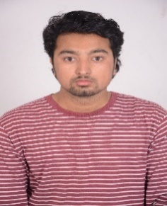

**PARAS CHAULAGAIN** is currently pursuing master’s degree in Information Technology from Charles Sturt University (CSU) and completed bachelor’s in Information Technology back in Nepal from Institute of International Management Science (IIMS) affiliated to Lovely Professional University (LPU), India. His research interest includes deep learning, machine learning, and medical image processing.